**Tips on Leading a Walk Audit**

From Mark Fenton

Walk audits are facilitated walks for an interdisciplinary group of community stakeholders, often led by design experts, with the following potential outcomes:

* **Education.** Guides people to *experience* and assess the “friendliness” of an area to active transportation (walking, biking, transit), not just look at it theoretically.
* **Inspiration.** Helps leaders and policy makers and residents to explore and imagine what could be possible in their community.
* **Practical planning.** Outstanding way to get everyone--professionals and not--actively involved in project or policy development, valuing each person’s input.

**Participants.** Anyone who can influence or is affected by the built environment: Planners, public works, engineers, architects, landscape architects; public health and safety, housing, transit, school officials; elected and appointed officials (city/county council, planning commission, school board); business and development leaders; and those who often lack a voice in planning: children, elderly, people of color, low income, or with disabilities.

**Distance.** Often 0.5 to 2.0 miles; for a 30 to 90-minute walk, allowing time to stop for observations and discussion. A one-hour, roughly 1.5-mile walk can work very well.

**Route.** Should be determined and pre-scouted by the facilitator(s) ahead of time, and include a mix of supportive and challenging (good & bad, below) settings for active transportation, with safe (out of traffic) places for the group to stop and talk.

* Good e.g.: Park, trail, walk- & bike-friendly facilities & downtown, traffic calming (curb extensions, islands, raised crossings), community garden, farmer’s market, etc.
* Bad e.g.: Wide roads, no crosswalks, speeding traffic; malls & sprawling low-density subdivisions, giant parking lots, no bike racks, “big box” retail & strip development.
* Surprises: Informal trails, bikes parked at trees or parking meters (or other evidence of user demand), overlooked gems (e.g. small neighborhood park or green- SummitGroup1grocer).

Four major elements of the walk.

* **Introductions**, brief, to connect the group and understand the mix of perspectives.
* **Education/set-up.** This could be an hour-long PowerPoint presentation, or a 10-minute discussion of elements that support community health. Either way, start the walk by first thinking about what supports active transportation (walk, bike, transit):
  + A varied mix of land uses (live, work, shop, play, learn, pray) in close proximity.
  + Good network for pedestrian, bicycle, and transit use (sidewalks, trails, bike lanes).
  + Functional, inviting site designs (buildings at the sidewalk, trees, benches, lights).
  + Safety and access for users of all ages, abilities, incomes (ramps, traffic calming).
* **The Walk.** Have participants use a 0 to 10 scoring system for considering the environment, 10 being the most supportive of active transportation, 0 the least. At occasional stops, have participants state their scores, and give examples of why it is what it is (“too much traffic, only a 4;” or “8: great trees & benches & lots of people”). No right or wrong answers, just a device to help all to observe and share.
* **Discussion/planning**. Immediately following a walk is an ideal time to develop specific conceptual plans, project details, and ordinance recommendations.

**A recommended “script” for facilitating a walk audit.**

Opening instructions - Remind walk participants of three rules.

1. **Be careful.** You are walking in the real world with real hazards; be careful crossing streets, watch out for traffic and one another, make room for pedestrians & cyclists.
2. **Think of all users.** Imagine very young or old users, those on bikes or accessing transit, or with disabilities (e.g. blind, in a wheelchair, on crutches), those pushing a stroller or pulling a grocery cart; those of different races, backgrounds, or incomes.
3. **Score the walk on the 0 to 10 scale**; 0 if it utterly discourages walking, cycling, and transit use, 10 if it is very encouraging. Instruct participants to be scoring on every step of the walk, and stop to discuss at points along the walk.

**During discussion stops.** Instruct participants to think of their scores since the start of the walk (or since the last ‘scoring’ stop), and then pass your hand over the group having them shout out their scores for all to hear as you pass them. First ask why they did not all give perfect 10’s, having them list challenges one at a time. Then ask why they did not give all 0’s, listing positives one at a time. Do not allow this to turn into a discussion of blame, just a summary of what you experienced and how it can be made better. Give all a chance to comment, and don’t let “professionals” or elected officials dominate the conversation!

**Typical questions about facilitating a walk audit . . .**

**1. What if the weather is challenging—rainy, snow on the ground, etc?**

I encourage participants to dress and mentally prepare for any typical conditions for that time of year. For example, rain and even snow is common in much of the country, and people still have to get to work, kids to school, etc. So why not get out and see what they are up against: Un-cleared sidewalks? Snow piled in crosswalks? Bike parking that is out in the open, uncovered, and unprotected? Transit stops without shelters? These are real-world conditions we should be forced to confront. Obviously horrific weather (frost-biting cold, dangerous lightning) would keep us inside, but that's all. Just in case I often prepare a "virtual" walk audit, going out ahead of time and taking photos of our planned route which we can show and discuss as we would a real-live walk.

**2. What if our meeting or event is occurring in an area that is very unappealing or unfriendly to walking?** I am very hesitant to use this as a reason not to go for a walk audit. No matter how unsavory, someone actually works or lives in the location where you'll be meeting, and no doubt they should still be able to get 30 or more minutes of physical activity a day, and to have access to healthy food choices. If there is no place reasonable to walk and no healthy food available within walking distance, then we're seeing a very real world example of the environment that many US residents face every day. Thus, if the meeting setting is not very conducive to walking, all the more reason to venture out and ask the question: How do we stop building stuff like this, and make places that are likely to be more supportive of routine physical activity and healthier lifestyles? How would we improve *this* for the people who live or work here every day?

**Videos on leading walk audits:**

Fenton’s tips on inclusive inter-disciplinary walk audits, with the National Coalition on Health, Physical Activity, and Disability (NCHPAD), Birmingham AL. (~3:00 mins.)

[https://youtu.be/DQ0rvd88iJQ​](https://youtu.be/DQ0rvd88iJQ)

Practical walk audit with interview in Oak Park, IL; (8:00 mins.)

<https://www.youtube.com/watch?v=KX3O-vDQIrs>

A concise summary of why building a world for free-range children and adults is Mark’s driving passion. (< 2:00 mins.)

<https://cantaloupe.wistia.com/medias/ofyte8zhl7>

**Select resources.**

*AARP Walk Audit Tool Kit*: <https://www.aarp.org/livable-communities/getting-around/aarp-walk-audit-tool-kit.html>

*AARP Pop-Up Placemaking Tool Kit,* a practical how-to guide for low-cost traffic calming. www.aarp.org/livable-communities/tool-kits-resources/info-2019/pop-up-tool-kit.html

*Slow Your Street: A How-to Guide for Pop-Up Traffic Calming*. trailnet.org/tag/plan4health/ Design, implementation, promotion, & evaluation tips on demo projects.

*The Tactical Urbanist’s Guide to Materials & Design,* by the Streets Plan Collaborative. Downloadable for free. [tacticalurbanismguide.com](http://tacticalurbanismguide.com)

*Quick Build Guide: How to Build Safer Streets Quickly and Affordably.* Practical guide; Alta Planning. <https://altago.com/wp-content/uploads/Quick-Build-Guide-White-Paper-2020-1.pdf>

*Active Living Research program;* www.activelivingresearch.org. Extensive on-line research and practical implementation bibliography.

*AmericaWalks*; [www.americawalks.org](http://www.americawalks.org). Leading pedestrian advocacy organization.

*Complete Streets initiative*; www.completestreets.org. National campaign to have all roads accommodate pedestrians, bicyclists, & transit as well as cars.

*Environmental Protection Agency smart growth initiative*, Washington, DC; www.epa.gov/smartgrowth. Excellent economic & implementation summaries.

*League of American Bicyclists*, Washington, DC; [www.bikeleague.org](http://www.bikeleague.org). *National advocacy group advancing the* Bike Friendly Communities *program.*

*Smart Growth America*, smartgrowthamerica.org. Advocacy & education on land use and transportation best practices; “improving lives by improving communities.”

*Pedestrian and Bicycle Information Center*, Chapel Hill, NC.; [www.pedbikeinfo.org](http://www.pedbikeinfo.org). A comprehensive resource; walk- & bike-ability checklists, design guides, & image library.

*Rails-to-Trails Conservancy*, Washington, DC.; www.railtrails.org*. Definitive trails resource.*

*Small Town and Rural Multimodal Networks*; ruraldesignguide.com. A leading design guide focused on practical, low-cost improvements for walking & bicycling.

*Safe Routes to School* programs; www.saferoutesinfo.org; saferoutespartnership.org. Information on organizing events & launching programs; national registry & data portal.

Walkscore.com. *Get a score from 0-100 on the walkability of any address in N. America!*Sample handout for participants: Google Map of the area and reminder notes.

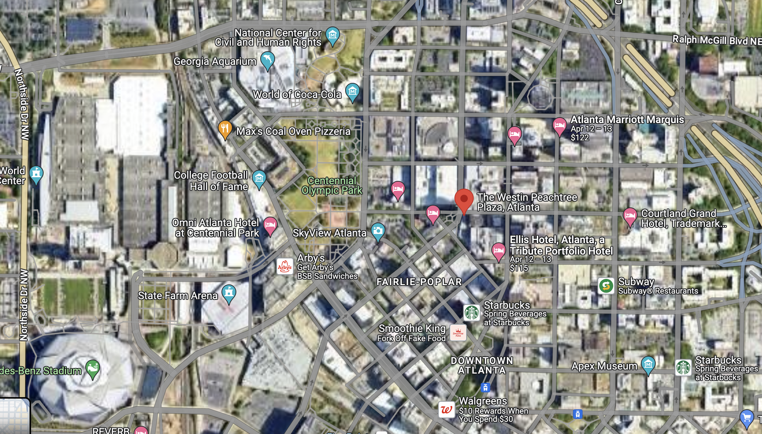

Think of the following while walking (multiple levels: land use, network, & site design) . . .

1. **Mixed use: Compact development with different types of destinations within walking, cycling, and transit distance.** Look for opportunities to live, work, shop, play, learn and pray.
2. **Network: A comprehensive and connected network of pedestrian, bicycle, and transit facilities;** sidewalks, trails, bicycle lanes, multi-use pathways, frequent affordable transit.
3. **Functional site designs: Destinations are designed to reward, not punish, those who arrive on foot, by bike and transit.** Buildings near the sidewalk, cars parked on street, behind, or beside buildings, and inviting street elements: bike parking, benches, awnings, plantings and shade trees, water fountains, quality transit stops, public art.
4. **Safety and accessibility for all: All ages, incomes, physical abilities and disabilities.** Curb ramps at intersections, painted crosswalks, pedestrian crossing signals with countdown timers, center median islands; traffic calming measures such as narrower lanes, mini-circles, & roundabouts.

Your notes (and mark on map):